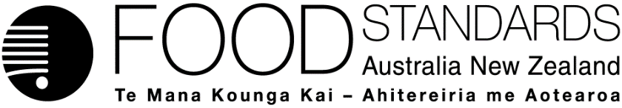

6 November 2018
[62–18]

Administrative assessment report – Proposal P1050

Pregnancy warning labels on alcoholic beverages

Brief Description of Proposal:  To consider a mandatory labelling standard for pregnancy warning labels on packaged alcoholic beverages. |  | Potentially affected standard:  2.7.1 – Labelling of alcoholic beverages and food containing alcohol  1.2.3 – Information requirements – warning statements, advisory statements and declarations
Procedure:  General | Estimated total hours:  Maximum of 650 hours  Reasons why:  The proposal will require social science and economic assessment and targeted consultation. | Provisional estimated start work:  Late October 2018

Other Comments or Relevant Matters:
This matter was considered by the Australia and New Zealand Ministerial Forum on Food Regulation at their meeting in October 2018. The outcomes from that meeting can be found in the Australia and New Zealand Ministerial Forum on Food Regulation Communique.

Decision
Proposal prepared

Date: 1 November 2018

Consultation & assessment timeframe
Proposed length of public consultation period:
6 weeks
Proposed timeframe for assessment:
Commence assessment (clock start) Late October 2018
Completion of assessment & preparation of draft food reg measure End Feb 2019
Public comment Early March to mid-April 2019
Board to complete approval Mid June 2019
Notification to Forum Late June 2019
Anticipated gazettal if no review requested September 2019

